**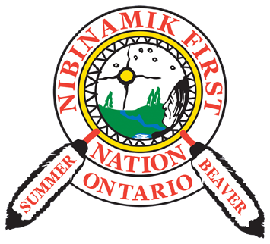***MEDIA STATEMENT*

# Wednesday, September 4, 2019 FOR IMMEDIATE RELEASE

**MATAWA CHIEFS COUNCIL SUPPORT NIBINAMIK FIRST NATION’S “JOURNEY TO OUR HOMELANDS” EVENT**

## **THUNDER BAY, ON:** The Matawa Chiefs Council is proud to support Nibinamik First Nation’s “Journey to Our Homelands” event, and wish the Elders of PinnaeMootang Inninug safe travels as they canoe back to their birthplace. These Elders hope to inspire all Matawa First Nations to think “beyond the Indian Act” and start reconnecting with each other through their lakes, rivers and trails, as they have done for millennia.

## Elders Tommy Yellowhead and Stephen Neshinapaise, both born at PinnaeMootang will be accompanied by a small group of youth as they travel an historic canoe route beginning near Nibinamik First Nation, paddling southward to their old village site. The Elders will be re-united with their birth place, and the accompanying youth will be able to experience the life of their Elders in their traditional homelands.

## 

A 2011 Unity Declaration signed by the nine (9) First Nation members of Matawa First Nations acknowledges the strength of working together. In order to foster the spirit of this Unity Declaration, Elders Yellowhead and Neshinapaise have taken on this initiative to spearhead the movement to re-assert jurisdiction in their traditional territory and implement the recommendations made under the Truth and Reconciliation Process.

Continuing their journey to self-determination, these Elders encourage other Matawa members to connect socially with each other through their rivers, lakes and trails; to demonstrate the current and traditional land usage for all Matawa communities and First Nation members.

Elders Yellowhead and Neshinapaise feel that the Matawa First Nations are stronger together, and that recognition of jurisdiction will not be attained unless it has been followed through by the First Nations.

There will be a homecoming reception at the old village of PinnaeMootang Lake upon the safe arrival of the canoes and passengers. This “Journey to Our Homelands” event will take place between September 4-7, 2019.

**Background**

* The Matawa Chiefs and Matawa First Nations represent 9 First Nations and respect the autonomy of each member First Nation
* This statement is without prejudice to the positions Long Lake #58 First Nation takes, or may take, on the issue of whether Long Lake #58 First Nation is a party to any Treaty

**— 30 —**

***For more information, please contact Carol Audet, Communications Manager at (807) 807-632-9663 or by email at: [caudet@matawa.on.ca](mailto:caudet@matawa.on.ca).***

**“Journey to Our Homelands” canoe route - September 4-7, 2019**

